**Covered QR (Medium)**

**We have uncovered a picture that contains a flag, but it seems to be missing some data. Can you recover the missing flag?**

*\*info on QR codes:* https://www.datagenetics.com/blog/november12013/index.html

**What version of QR Code is present in the image?**

Answer: model 2

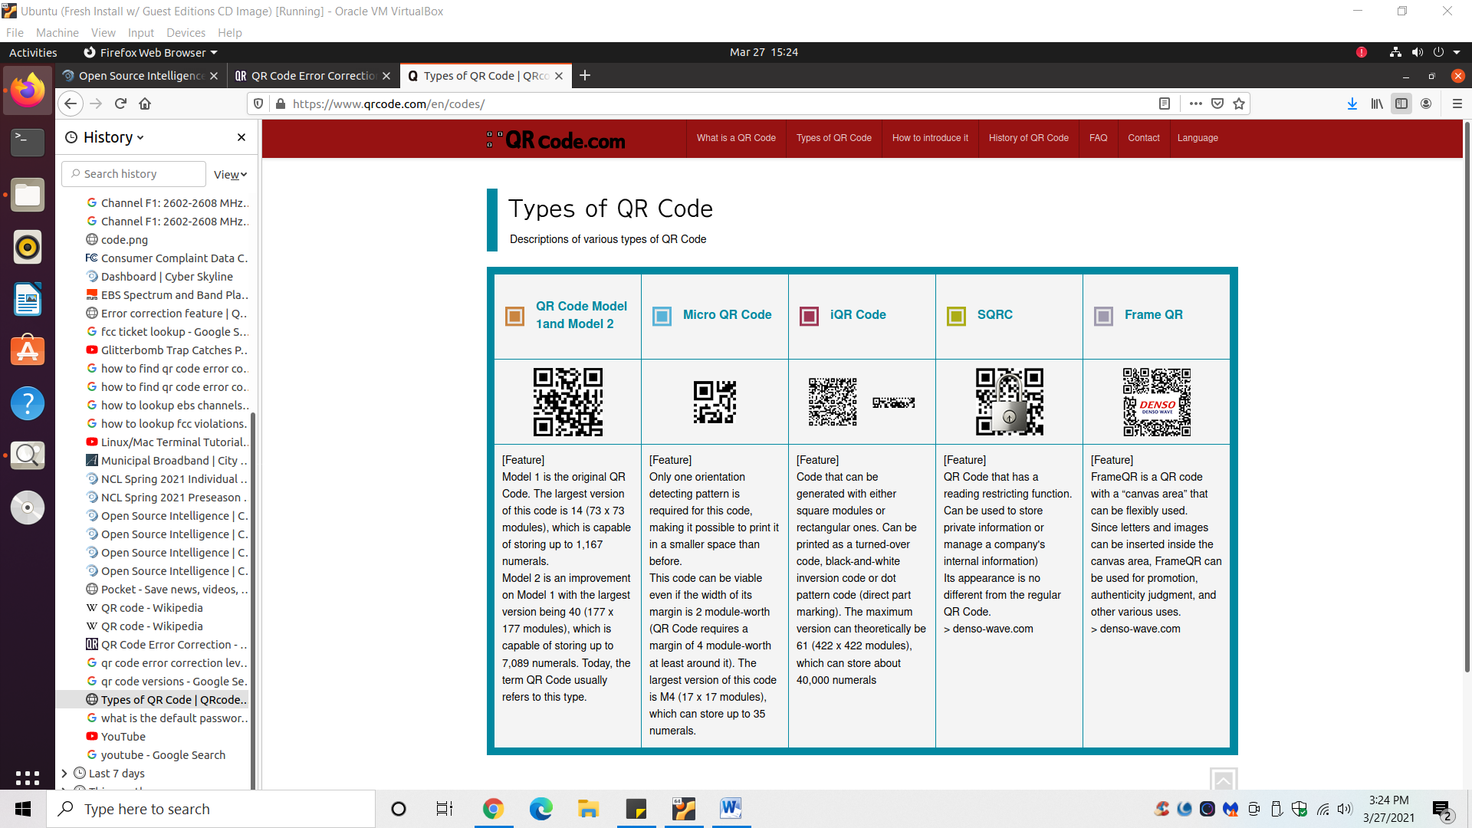

**What is the error correction level?**

Answer: H

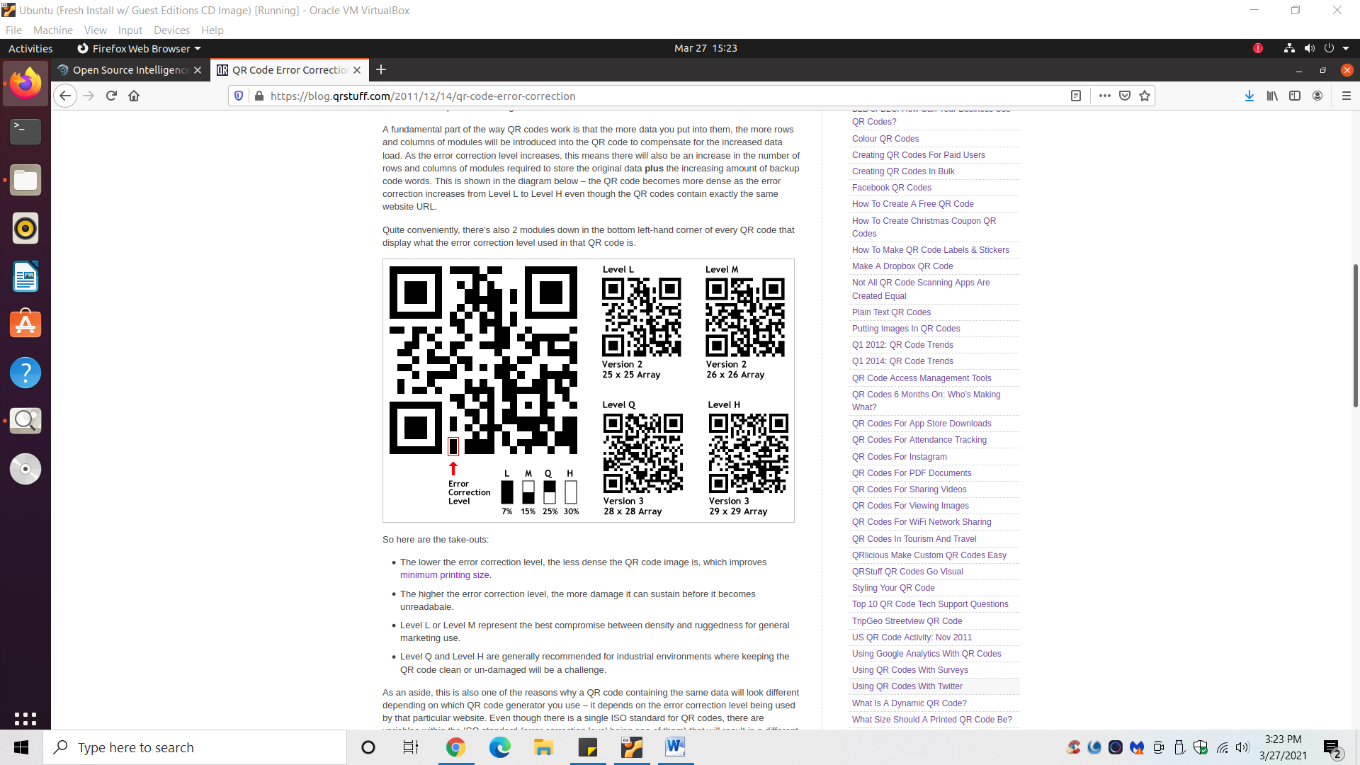

**What is the number for the mask pattern?**

Answer: 011

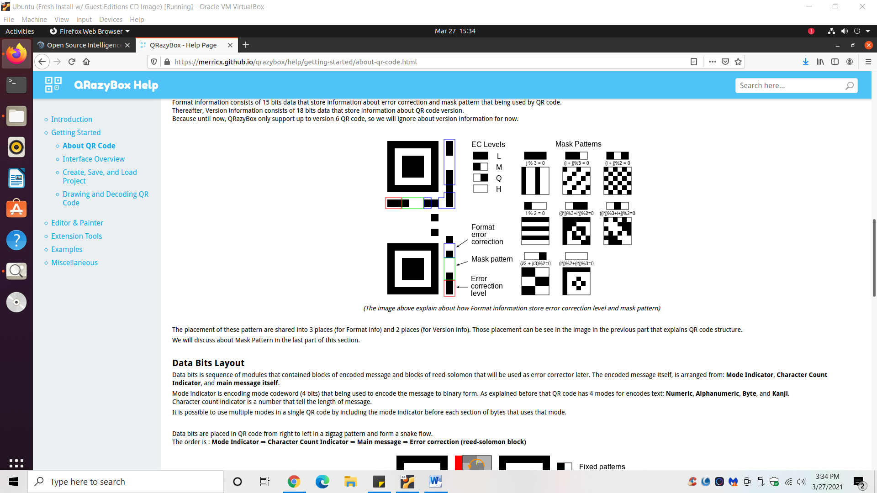

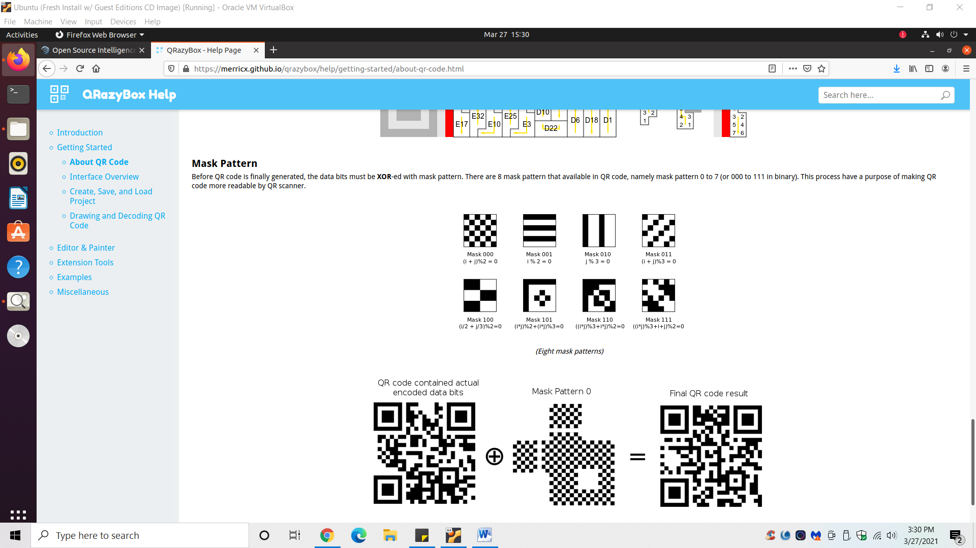

**What is the flag?**

1. Photoshop in a white box over the obstructed part of the QR code.
   1. Went into MS word and put a white rectangle over the obstruction.
   2. Screenshot the new QR code.
   3. Crop screenshot image.

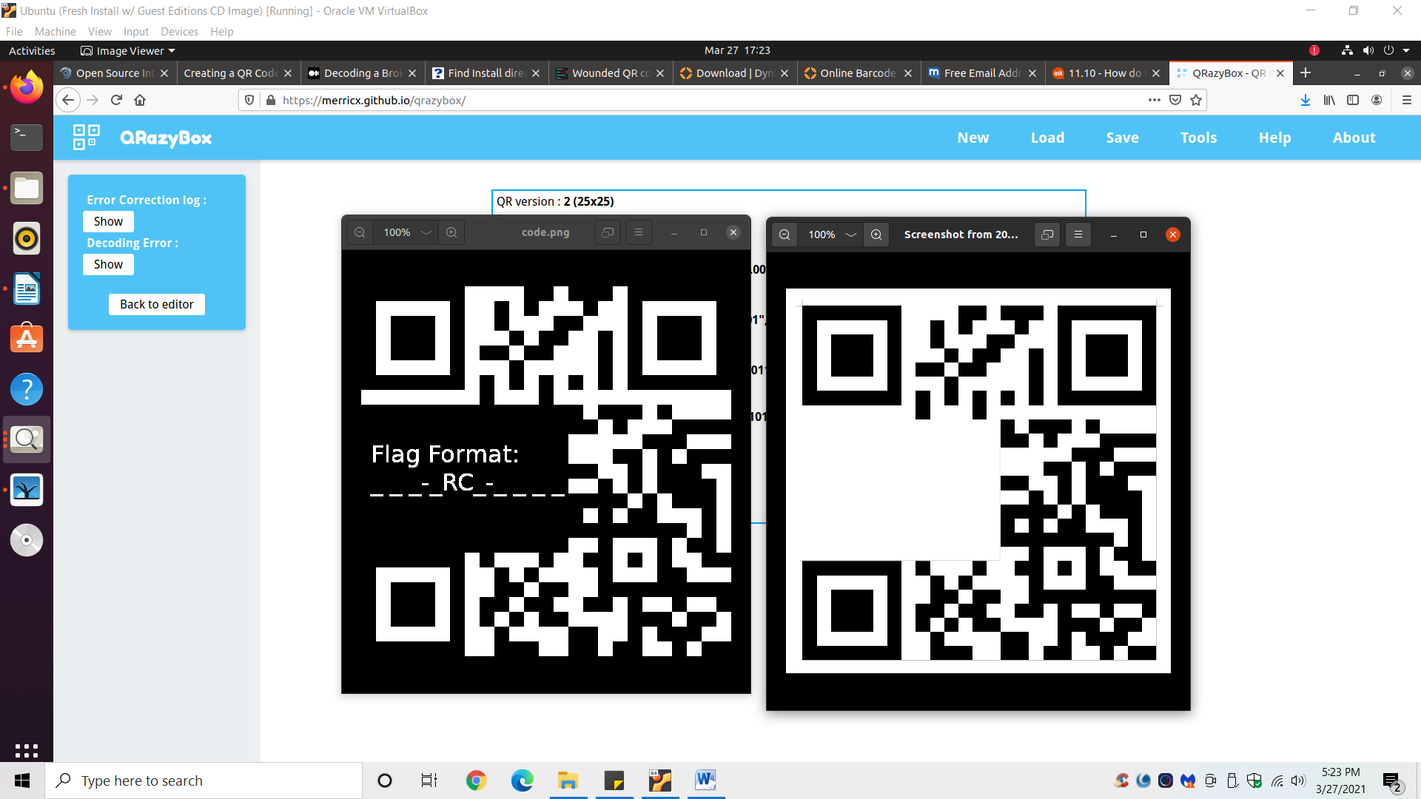

*Left = original QR code Right = altered QR code w/ white box

1. Go to QRazyBox.com.
2. Upload altered QR code image.

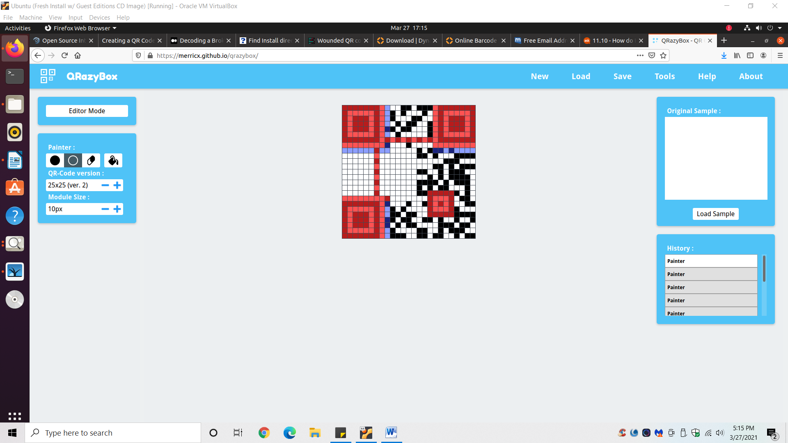

1. Go to Tools 🡪 Extract QR Information.
2. Flag appears at bottom of extracted info.

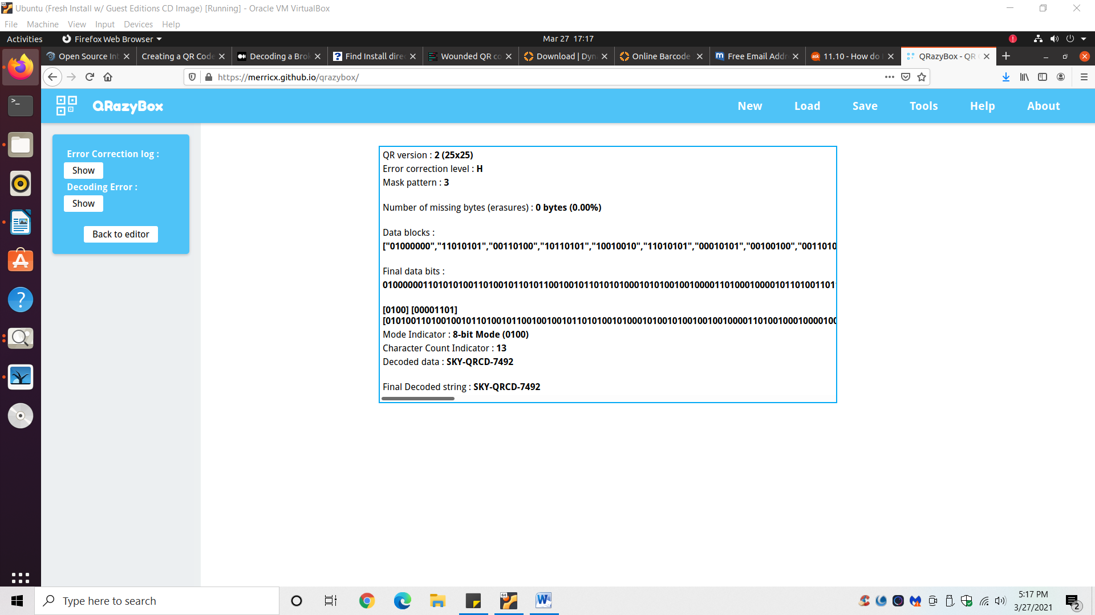

1. Answer: SKY-QRCD-7492